CO4 AT 2-INDUSTRY-BASED PROBLEM

Name:G.Krishitha
Reg.no:192524451

1.A cybersecurity system must detect malicious patterns in large volumes of network traffic data. Design and implement an optimized pattern-matching solution using suitable string-matching algorithms. Consider constraints such as real-time processing and high data throughput. Evaluate the performance based on detection accuracy and response time.
CODE: 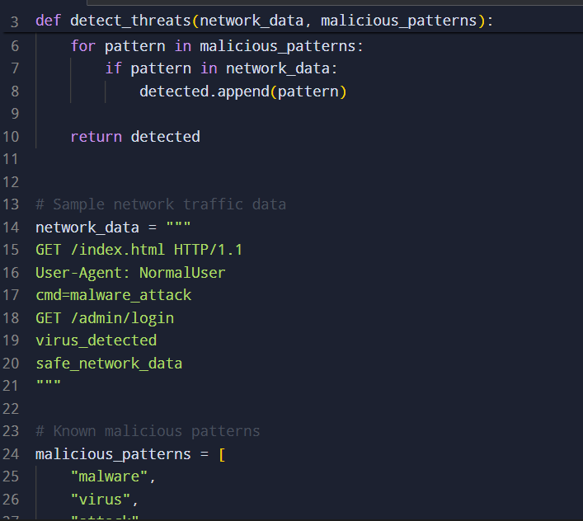OUTPUT: 